**The maps below show the changes in the art gallery ground floor in 2015 and present day.**

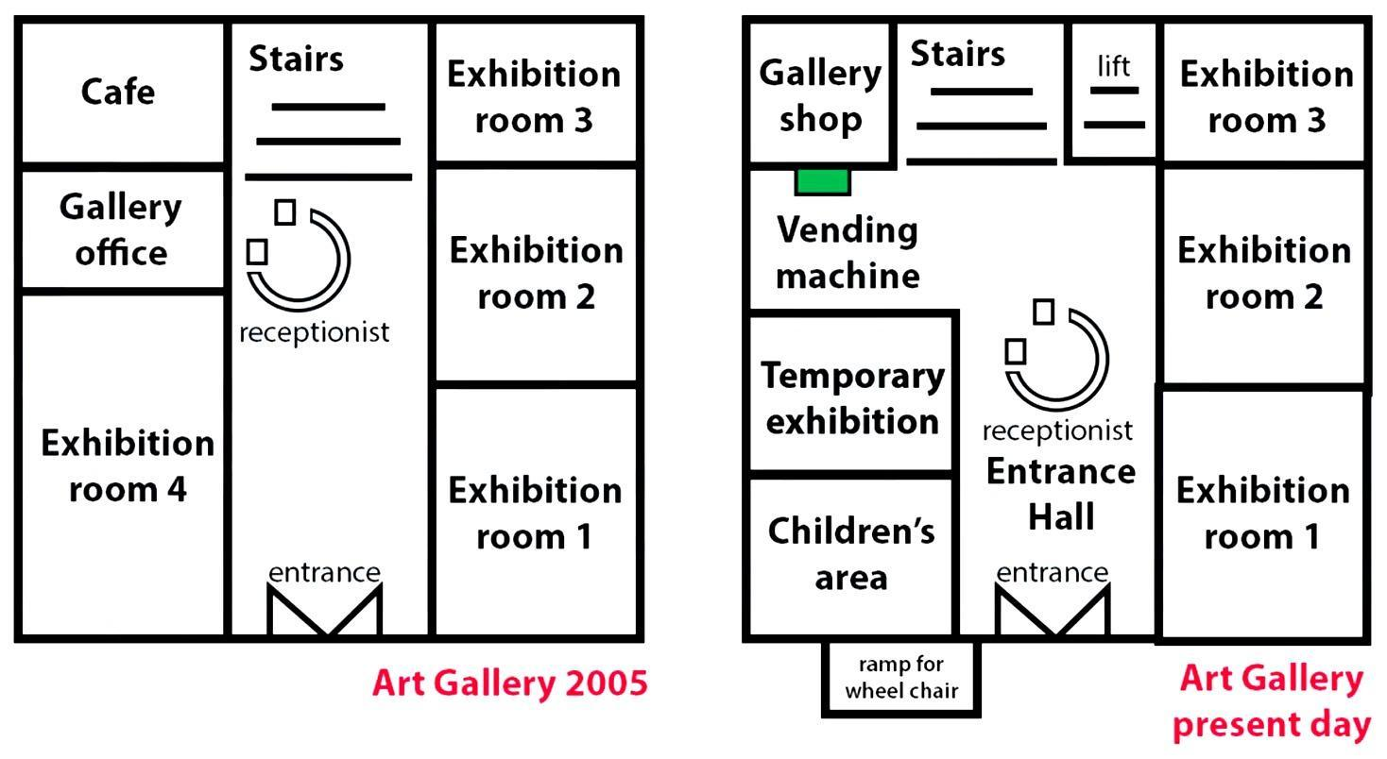

* Cách viết dạng map <https://www.ieltstutor.me/blog/map>

Given is the map comparing the layout of the art gallery ground floor between 2005 and the present day.

Overall, it is clear that the gallery office has been demolished, while provision for vending machine and ramp for wheel chair is now available.  **→ Overall**

**In** 2005, there were four exhibition rooms in the art gallery, whereas, one of those has replaced with a children’s area and temporary exibition in the present day. On the top left corner of the map, the gallery shop is built as an alternative to the café. In addition, the receptionist is moved from the left of the entrance hall to the center. At the bottom of the art gallery, the ramp for wheel chair has been added in the present day. On the opposite side of entrance hall, the stair is unchanged and the lift is added next to it. Finally, a vending machine has now replaced the gallery office, which was located in 2005. **⇒ Chia bố cục Task 1 & dạng Map nói riêng chưa được nhé, còn lộn xộn**

⇒ Xem lại bố cục Task 1: Intro - Overall - **Body 1 - Body 2** ⇒ Viết 2 đoạn thân bài chia bố cục map rõ ràng vào nhé

⇒ Dạng map chia bố cục: Body 1: **Map 2005,** Body 2: **Map Present**

* **Body 1: Map 2005** (mô tả vị trí các buildings, rooms, facilities có vào năm 2005): <https://www.suabaiieltswriting.com/blog/cach-mo-ta-map-ielts-writing-tu-bao-quat-den-chi-tiet-tu-ngoai-vao-trong-tu-phai>
* **Body 2: Map Present** (mô tả tất cả sự thay đổi theo thứ tự thống nhất với body 1 - cái nào mất đi, được thay thế, di chuyển & giữ nguyên)

**⇒ Học lại BỐ CỤC DẠNG MAP nha:**  [**https://www.ieltstutor.me/blog/map**](https://www.ieltstutor.me/blog/map)

[**IELTS TUTOR**](https://www.ieltstutor.me/blog/sua-de-thi-ielts-writing-22-8-2020) **lưu ý:**

* **Dạng process này thì đã rất quen thuộc với các bạn học sinh** [**lớp IELTS ONLINE WRITING 1 KÈM 1 của IELTS TUTOR**](https://www.ieltstutor.me/intensive-writing) **rồi nhé**
  + **Overall:**
    - **While the eastern part of the gallery has remained more or less intact over time, the opposite side has undergone significant transformations, with the whole area becoming more accessible for the disabled. >> IELTS TUTOR hướng dẫn** [**PHÂN BIỆT "REMAIN & RETAIN" TIẾNG ANH**](https://www.tutorchuyenanh.com/blog/phan-biet-remain-retain-trong-tieng-anh)
  + **Body 1: Art Gallery, 2015**
    - **Originally, the gallery was designed merely for its exhibition purpose, and visitors could enter the hall through the entrance in the south of the building. >> IELTS TUTOR hướng dẫn** [**Cách dùng danh từ "remains" tiếng anh**](https://www.ieltstutor.me/blog/cach-dung-danh-tu-remains-tieng-anh)
    - **Inside the hall, there was a reception desk to welcome visitors, which led to a staircase in the north end.**
    - **The remaining part simply consisted of functional areas with a set of 3 exhibition rooms on the eastern wing, one large exhibition space together with an office taking up the entire southwestern corner, and a café in the northwest. >> IELTS TUTOR hướng dẫn** [**Cách diễn tả & paraphrase "phần còn lại" (remaining) tiếng anh**](https://www.ieltsdanang.vn/blog/cach-dien-ta-paraphrase-phan-con-lai-remaining-tieng-anh)
  + **Body 2: Art Gallery, present day**
    - **At present, the location has become modernized and versatile, providing more facilities for visitors, especially with the addition of a wheelchair slope right outside the entrance to the west and a lift next to the stairs. >> IELTS TUTOR hướng dẫn** [**Word form của "remain"**](https://www.luyenthidaihoctienganhonline.com/blog/word-form-remain)
    - **Another alteration that happened was the relocation of the reception towards the entrance of the gallery.**
    - **To the west, exhibition room 4 was converted into a children’s indoor playground and one smaller room for temporary display while a gallery shop and a vending machine were opened in place of the original gallery office and the cafe. >> IELTS TUTOR hướng dẫn** [**Các từ / cấu trúc thường được paraphrase IELTS WRITING**](https://www.suabaiieltswriting.com/blog/ielts-writing-task-1-tu-cau-truc-paraphrase)